VECTOR DATABASE

What is a Vector Database?
- A vector database is a collection of data stored as mathematical representations.

- Vector databases make it easier for machine learning models to remember previous inputs, allowing machine learning to be used to power search, recommendations, and text generation use-cases.

Classically, when people thought of “data” they thought of spreadsheets and charts. This is what we now call structured data, and it only makes up a very small fraction of the data we have access to these days.
This type of data fits well in a traditional database. But all the unstructured data, things like images and blog posts where there are no neat tables of columns and rows, how can that best be stored?

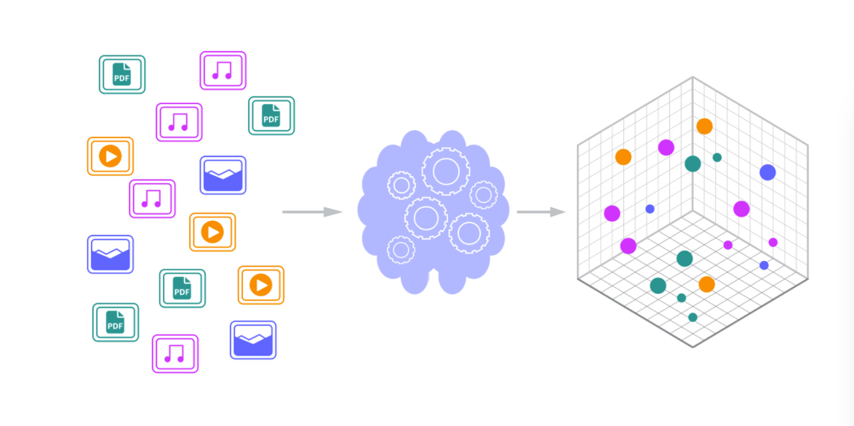

- A vector database is a type of database designed for this very purpose: it not only stores unstructured data like images and blog posts but also the vector embeddings of these items.
- Through a process called vectorization we can transform complex, high-dimensional unstructured data into a lower-dimensional, numerical form that captures the essence of the data and then store each vector.

- Vector databases excel at retrieving semantically similar data points, making them ideal for managing unstructured data like text, images, and audio.

- While computationally intensive, vector databases are designed to scale efficiently, accommodating the growing demands of AI applications.

What are Vectors?
A vector is an array of numerical values that expresses the location of a floating point along several dimensions.
In more everyday language, a vector is a list of numbers, like: {12, 13, 19, 8, 9}. These numbers indicate a location within a space, just as a row and column number indicates a certain cell in a spreadsheet (e.g. "B7").

How do Vector Databases Work?
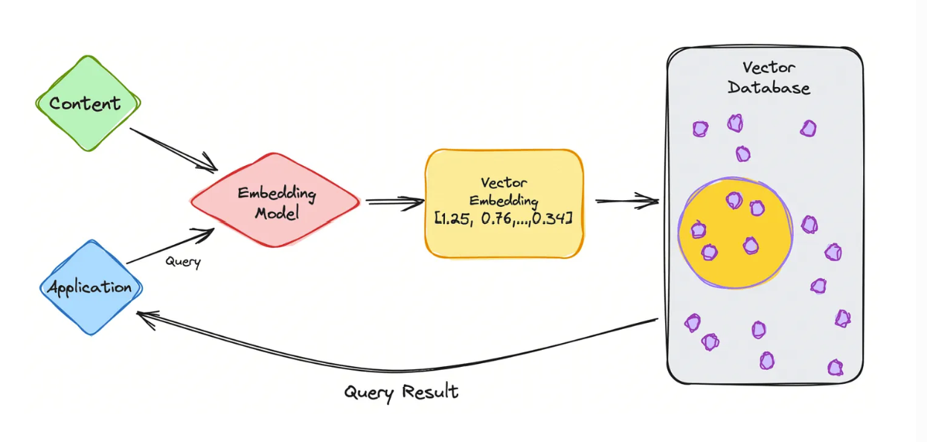

- When a user query is initiated, various types of raw data including images, documents, videos and audio.

- All of this, which can be either unstructured or structured, are first processed through an embedding model.

- This model is often a complex neural network, translating data into high-dimensional numerical vectors and effectively encoding the data’s characteristics into vector embeddings — which are then stored into a a vector database like SingleStoreDB.

- When retrieval is required, the vector database performs operations (like similarity searches) to find and retrieve the vectors most similar to the query, efficiently handling complex queries and delivering relevant results to the user.

- This entire process enables the rapid and accurate management of vast and varied data types in applications that require high-speed search and retrieval functions.

Popularly used vector DB’s:

- FAISS:

FAISS is an open-source library designed for efficient similarity search and clustering of dense vectors, enabling applications like recommendation systems and image search.
https://python.langchain.com/docs/integrations/vectorstores/faiss/

- ChromaDB:

Chroma (or ChromaDB) is an open-source vector database designed specifically for AI, embeddings, and retrieval-augmented generation (RAG) workflows.
It’s lightweight, developer-friendly, and works well for storing and querying embeddings generated by LLMs.
https://www.trychroma.com/
- Weviate:

- Weaviate is an open-source, cloud-native vector database that’s built specifically for AI-powered search and RAG (Retrieval-Augmented Generation) workflows.
https://weaviate.io/

Feature / Aspect | Weaviate | ChromaDB | FAISS
Type | Full-featured vector database | Lightweight vector database (LLM-focused) | Vector search library (not a DB)
License | Open Source (BSD-3-Clause) | Open Source (Apache 2.0) | Open Source (MIT)
Free to Use | Yes (self-hosted) | Yes (self-hosted) | Yes
Storage Backend | Built-in DB with persistence | Built-in (SQLite/PostgreSQL) | No built-in persistence (you save/load index manually)
Scalability | High — distributed, sharding, cloud-native | Medium — best for small to medium datasets | Limited to a single machine
Metadata Filtering | Advanced filters, hybrid search | Basic filters | None natively
Hybrid Search | Yes (vector + keyword) | No | No
API Access | REST, GraphQL, gRPC | Python API | Python/C++ API
Indexing Methods | HNSW, IVF, flat, PQ, etc. | HNSW | IVF, HNSW, PQ, Flat, GPU acceleration
Built-in Embeddings | Yes (integrates with OpenAI, Hugging Face, etc.) | No (you pass embeddings) | No (you pass embeddings)
Persistence & Reload | Automatic | Automatic | Manual(store/reload index)
Ease of Use | Medium (setup server) | Easy (Python package) | Medium (manual setup in code)
Integration with LangChain | Yes | Yes | Yes

Task : AI-Powered Conversational News Retrieval and Categorization System using Vector Database and LLM

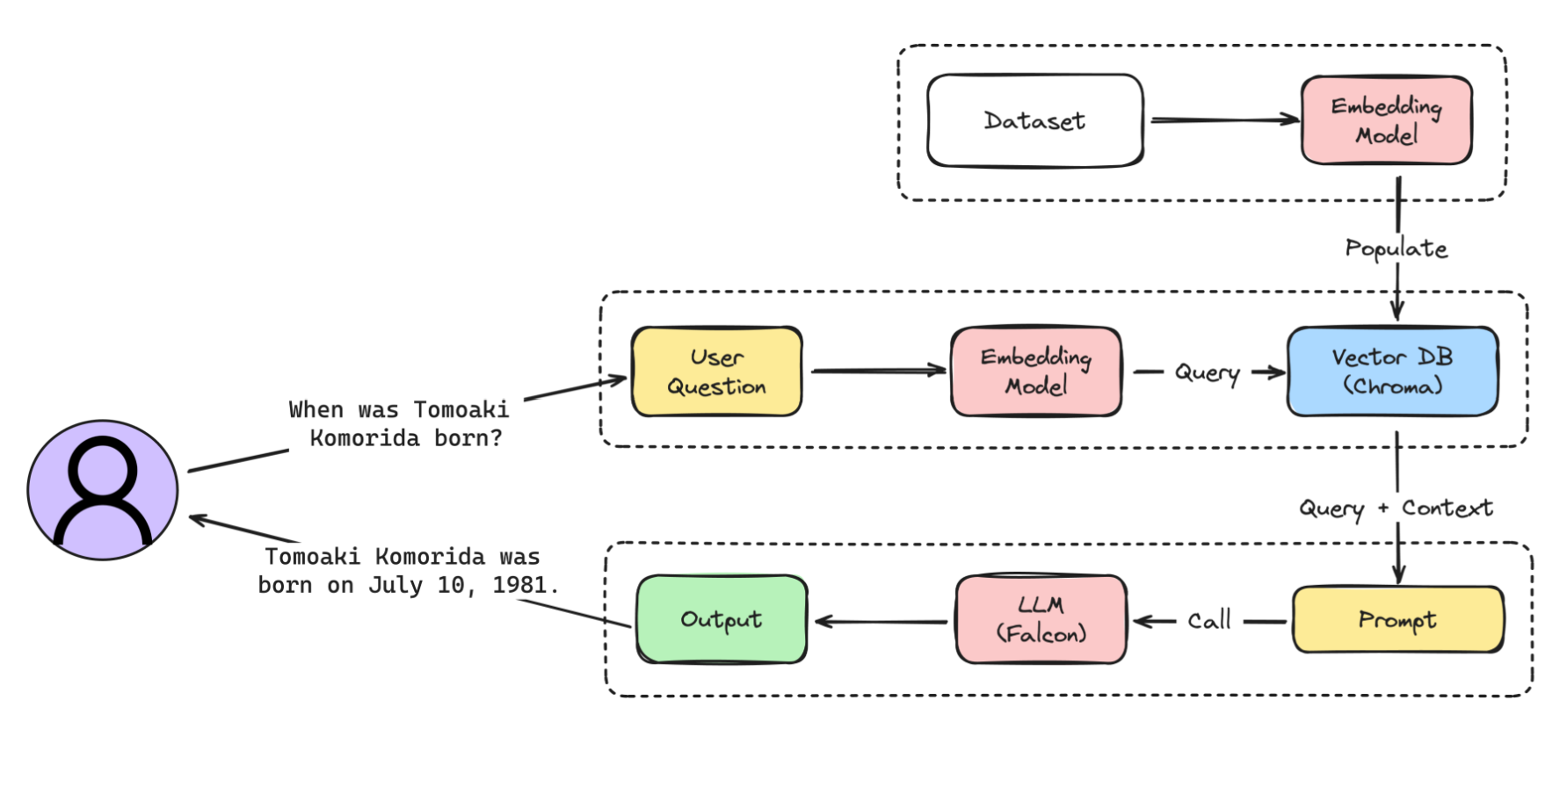
Logic Flow
- Load and Prepare Data:
  - Read news headlines and categories from an Excel file.
  - If sentiment is missing, calculate it using TextBlob (positive, negative, neutral).
  - Store category and sentiment as metadata for each headline.

- Convert Headlines to Vectors:
  - Use an embedding model (e.g., Ollama, OpenAI, Hugging Face) to convert each headline into a vector representation.
(In the task, mxbai-embed-large model was used through ollama embeddings)
  - This vector captures the semantic meaning of the headline.

- Store in Vector Database:
  - Save the headline vectors along with their metadata in a vector database (e.g., FAISS, Qdrant, Milvus, Weaviate).
(In the task, FAISS DB was used)
  - This enables fast similarity searches.

- Semantic Retrieval:
  - When a user enters a query, convert it into a vector using the same embedding model.
  - Search the vector DB for the closest matching headlines based on semantic similarity.
  - Optionally, apply metadata filters (e.g., only positive news in the sports category).

- Conversational AI Layer:
  - Pass the retrieved headlines to a Language Model (LLM).
(In this task, llama3 through ollama was used)
  - The LLM reformulates them into a natural, conversational answer for the user.

- Interactive Chat:
  - Maintain chat history so that follow-up queries use previous context.
  - Continue retrieving and summarizing relevant headlines until the user exits.

Role of LangChain in this task:
LangChain acts as the orchestration framework that connects your Vector Database, Embeddings Model, and LLM into a single conversational workflow.
(Python file of the program is in the same folder as this)
Challenges:
- Inaccurate or Irrelevant Answers:
  - The system sometimes returns responses that are factually incorrect or not aligned with the user query, reducing trustworthiness.
- Hallucinations by LLM:
  - The language model occasionally generates information not present in the retrieved documents, leading to misleading outputs.
- Retrieval Quality Issues:
  - Relevant articles may be missed due to limitations in embedding quality, vector search precision, or improper chunking of source data.
- Context Misinterpretation:
  - Even when correct documents are retrieved, the LLM may misinterpret or overlook key points, causing incomplete or vague responses.
- Prompt Sensitivity:
  - Slight variations in query phrasing can significantly change retrieval and output quality, affecting system consistency.
- Scalability Concerns:
  - As the dataset grows, maintaining fast and accurate retrieval without compromising on quality becomes challenging.

Proposed Solutions:
- Improve Embedding Quality:
  - Switch to higher-precision embedding models (e.g., mxbai-embed-large, text-embedding-3-large) to ensure better semantic matching during vector search.
- Optimize Chunking Strategy:
  - Experiment with smaller or context-preserving chunk sizes and overlap to improve retrieval of complete and relevant information.
- Hybrid Search Approach:
  - Combine vector similarity search with keyword-based (BM25) retrieval to improve recall for specific terms and rare entities.
- Retrieval-Augmented Re-Ranking:
  - Implement a re-ranking model to reorder search results based on contextual relevance before passing them to the LLM.
- LLM Fine-Tuning or Model Switch:
  - Use instruction-tuned, hallucination-resistant LLMs (e.g., Mistral-7B-Instruct, LLaMA 3-8B-Instruct, Claude 3.5 Sonnet, Falcon) or fine-tune the current model with domain-specific data.
- Prompt Engineering & Guardrails:
  - Add system prompts that restrict the LLM to only use retrieved context and explicitly answer "Not Found" if relevant information is missing.
- Feedback Loop for Continuous Improvement:
  - Capture user feedback on answer accuracy to iteratively improve retrieval, prompt design, and model performance.

************

